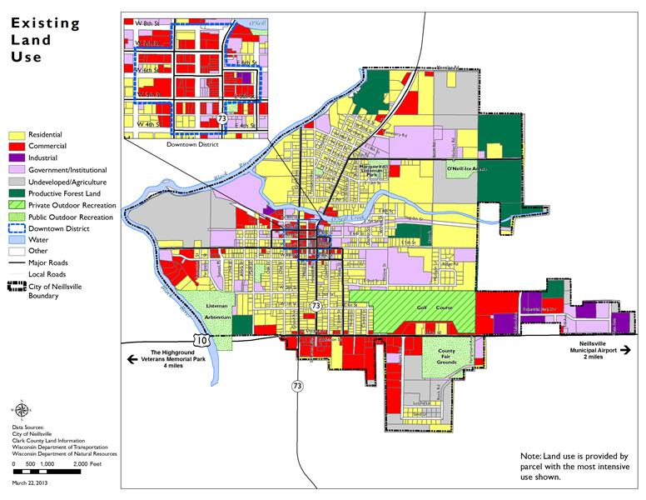

**THIS MAP DOES NOT REPRESENT THE SPECIFIC ZONING OF INDIVIDUAL LOTS**